USE THE "jES-HEAD" BUTTON FOR THE TITLE

USE THE "jES-AUTHORS" BUTTON FOR AUTHORS NAMES (Full names)
¹ Use the "jES-Affiliation" button for the address
* Corresponding author. Author name, Tel. +00 XXXXXX, e-mail. ...... (Use the "jES-Affiliation" button)

 |  | A B S T R A C T
Keywords: |  | For the abstract text use the "jES-Abstract" button
Use the "jES-Keywords" button  Keyword 1  Keyword 2  Keyword 3  Keyword 4  Keyword 5 |  | For the abstract text use the "jES-Abstract" button

I. INTRODUCTION (Use "jES-TITLE1" button)

For the text use the "jES-Text" button.

II. MATERIALS AND METHODS ("jES-TITLE1" button)

II.1 Chemicals (for the 1st subtitle use the "jES-Title2" button)

For the text use the "jES-Text" button

II.2 Measurements ("jES-Title2")

II.2.1 Samples preparation (for the 2nd subtitle use "jES-Title3")

For the text use the "jES-Text" button

II.2.2 Chemical analysis ("jES-Title3")

For the text use the "jES-Text" button

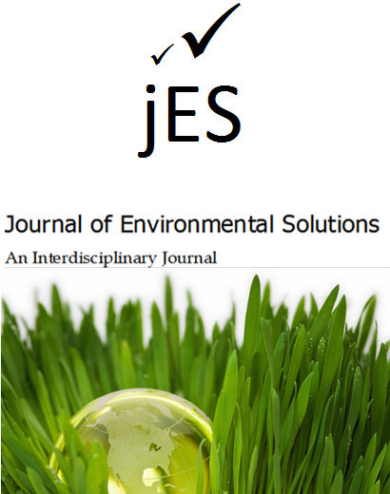

Fig. 1. For figure captions use "jES-Tab_Fig_captions" button

II.3 Data analysis ("jES-Title2")

For the text use the "jES-Text" button

III. Results and Discussion (“jES-TITLE1")

For the text use the "jES-Text" button

Table 1. For table captions use "jES-Tab_Fig_captions" button

Column 1ª | Column 2 | Column 3
1 | Data 1.1 | Data 1.2
2 | Data 2.1 | Data 2.2
3 | Data 3.1 | Data 3.2
4 | Data 4.1 | Data 4.2
ª Table footnote (use "jES-table_footnote" button)

IV. Conclusions ("jES-TITLE1”)

For the text use the "jES-Text" button

ACKNOWLEDGMENTS (" jES-TITLE1")

For text of the acknowledgments use the “jES-Abstract” button

REFERENCES ("jES-TITLE1")

For the references use the "jES-Reference" button.

Lipton, R.A., 2000. The art of writing a scientific article. J. Sci. Commun. 163, 51-59.

