example article

firstnameauthor1 lastnameauthor1^{1*}; firstnameauthor2 lastnameauthor2¹; firstnameauthor3 lastnameauthor3²
¹ University of USA
² University of Europe
* Corresponding author. Lastnameauthor1, Tel. +00 111222333, e-mail: nameauthor@university.us

 |  | A B S T R A C T
Keywords: |  | Here comes the abstract of the example article. The abstract must be informative and concise, giving an overview and essential information such as the purpose of the research, the principal results and major conclusions. It should not exceed 300 words. Authors should remember that the abstract is often the only portion of a paper read, as in abstracting journals, and the use of unusual acronyms or abbreviations should be avoided.
Keyword 1
Keyword 2
Keyword 3
Keyword 4
Keyword 5

I. INTRODUCTION

Include a clear description of the aims of the investigation (without summarizing the work itself), and a brief statement of previous relevant work with references.

II. MATERIALS AND METHODS

Methods should be described in sufficient detail to allow the experimental work to be reproduced. Methods already published should be indicated by a reference: only relevant modifications should be described. Give information on statistical design (including replication) of each experiment where appropriate.
The supplier and its location (city and country) should be included for all equipment and products identified in the methods section. Computer software should be identified by name and location of the developer.

Depending on your work, you will need to divide the materials and methods under different subtitles. An example follows.

II.1 Chemicals

Text about chemicals.

II.2 Measurements

II.2.1 Samples preparation

Text about samples preparation.

II.2.2 Chemical analysis

Text about chemical analysis.
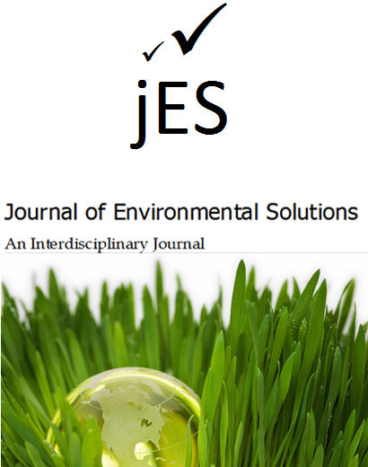

Fig. 1. Journal of Environmental Solutions

II.3 Data analysis

Text about the data analysis.

III. Results and Discussion

Present the results concisely, using tables or illustrations for clarity. Avoid repeating the same data in different forms. State clearly the form of the experimental error and the statistical significance of the results. Do not overstate the precision of the measurements.
The results should be discussed and compared with those available in literature.

Table 1. Interesting data

Column 1ª | Column 2 | Column 3
1 | Data 1.1 | Data 1.2
2 | Data 2.1 | Data 2.2
3 | Data 3.1 | Data 3.2
4 | Data 4.1 | Data 4.2
ª Table footnote

IV. Conclusions

The main conclusions drawn from results should be presented in a short conclusions section. Do not merely repeat the content of preceding sections.

ACKNOWLEDGMENTS

Authors should acknowledge the source of financial grants and other fundings, and declare any industrial links or affiliations. The contribution of colleagues (e.g., providing language help, writing assistance or proof reading the article, etc.) or institutions can also be acknowledged. Personal thanks and thanks to anonymous reviewers should not be included.

REFERENCES

References in the text consist of the surname of the author(s), followed by the year of publication in parentheses, or the year of publication only, depending on the narrative context. All references cited in the text should be given in the reference list and vice versa. If the same author(s) is cited in more than one publication in the same year, lower-case letters (a, b, c...) are appended to the year in the first and succeeding citations. Groups of references should be listed first alphabetically, then chronologically.

Lipton, R.A., 2000. The art of writing a scientific article. J. Sci. Commun. 163, 51-59.
Mettam, G.R., Adams, L.B., 1999. How to prepare an electronic version of your article, in: Jones, B.S., Smith , R.Z. (Eds.), Introduction to the Electronic Age. E-Publishing Inc., New York, pp. 281-304.
OJEC, 2001. Decision nº 2455/2001/EC, of the European parliament and of the Council of 20 November 2001, establishing the list of priority substances in the field of water policy and amending Directive 2000/60/EC. Off. J. Euro. Comm., L 331, 1-5.
SPSS, 2006. SPSS Software, Version 12.0. SPSS Inc. Chicago, IL. (Freeware and Shareware software should not be cited in references.)
Strunk Jr., W., White, E.B., 1979. The Elements of Style. third ed, Macmillan, New York.

